Variable Assignment

Esyst-131- Week 01

This worksheet should be completed following the Week 01x00 – Data Variables Presentation

*Found in the Lectures section of the week’s modules.*  You are **strongly** encouraged to have the Python interpreter or an IDE of your choice open evaluate the questions and ensure your answers are correct.

# Testing your answers:

Open your Python interpreter:

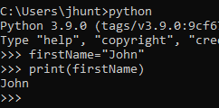

# Variable Declaration:

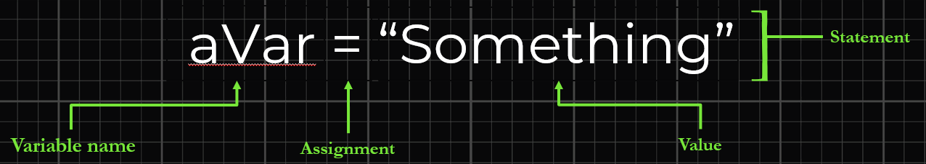

## Complete the following Declarations and Give their outputs:

Example: Declare a variable firstName with a value of “John”

In order to get the output, you need to pass the variable to the print() function like this: **print(firstName)**

Statement: firstName=”John”

Output: ‘John’

1. Declare a variable **lastName** with a value of “**Smith**”.

Statement:

Output of, *print(lastName)*:

2. Declare a variable **firstName** with a value of “**Rajat**”.

Statement:

Output of, *print(firstName)*:

3. Declare a variable **age** with a value of **53**.

Statement:

Output of, *print(age)*:

4. Declare a variable **favDrink** with a value of “Cocoa”

Statement:

Output of, *print(****favDrink****)*:

5. Declare a variable **favNumber** with a value of **42**

Statement:

Output of, *print(favNumber)*:

# Multiple Assignments

## Context:

You can make multiple declarations in one statement. Consider:



Here we declared three variables: **a**, **b**, and **c**

The values are (respective to the order they are declared):

12, “robots”, “Ada Lovelace”

The results:

|  |  |
| --- | --- |
| **Variable** | **Value** |
| a | 12 |
| b | robots |
| c | Ada Lovelace |

Print the results:



Or print a single variable:



## Make the following declarations:

Declare the variables: x, y, and z with the values: “Mars”, “Orion”, 1.2

Statement:

1.) Output of, print(x,y,z)

2.) Output of, print(y)

3.) Output of, pring(z,y,x)

# Overwriting Values:

1. Declare a variable **favFood** with a value of “Pizza”; then declare favFood with the value “**Lasagna**”

Statement:

Output of, *print(favFood)*:

2. Declare a variable **favNumber** with a value of **42**; then declare favNumber with the value “**eight**”

Statement:

Output of, *print(favNumber)*:

3. Declare a variable **favDay** with a value of **“Friday”**; then declare favDay with the value “**Thursday**”

Statement:

Output of, *print(****Thursday****)*:

# Edge Cases:

1. Declare a variable ‘**_stockPrices’ (note the underscore)** with a value of “120.00”

Statement:

Output of, *print(_stockPrices)*:

2. Declare a variable ‘**2books’** with a value of “A Tale of Two Cities”

Statement:

Output of, *print(2books)*:

3. Declare a variable **‘def’** with a value of “New Definition”

Statement:

Output of, *print(def)*:

# Valid Variables?

Look at the declarations below and assess whether they are valid or not:

1.) words =

2.) career = billionaire

3.) nextJob = “Master Coder”

4.) carsInStock = “3”

5.) tiresOnVehicle = 4

6.) and = 32

7.) _Rapper = “Busta Rhymes”

8.) 2pac = “Greatest west coast rapper”

9.) Critical Thought Question:

Will assigning values to: variable1, Variable1, and VARIABLE1 ; overwrite one another? Yes or No?

Why or Why not?

# Answer Sheet:

## Variable Declaration

1. Output of, *print(lastName)*: Smith
2. Output of, *print(firstName)*: Rajat
3. Output of, *print(age)*: 53
4. Output of, *print(****favDrink****)*: Cocoa
5. Output of, *print(favNumber)*: 42

## Multiple Assignments

1. Output of, print(x,y,z): Mars Orion 1.2
2. Output of, print(y): Orion
3. Output of, pring(z,y,x): 1.2 Orion Mars

## Overwriting Values

1. Output of, *print(favFood)*: Lasagna
2. Output of, *print(favNumber)*: eight
3. Output of, *print(favDay)*: Thursday

## Edge Cases

1. Output of, *print(***_stockPrices’***)*: 120.00
2. Output of, *print(***2books***)*: SyntaxError: invalid syntax
3. Output of, *print(def)*: SyntaxError: invalid syntax

## Valid Variables

1.) words Valid Invalid

2.) career Valid Invalid

3.) nextJob Valid Invalid

4.) carsInStock Valid Invalid

5.) tiresOnVehicle Valid Invalid

6.) and Valid Invalid

7.) _Rapper Valid Invalid

8.) 2pac Valid Invalid

9.) Critical Thought Question:

Overwritten Not overwritten

Why?

Variable declaration is case sensitive.